

Dr. Patrick, Vazquez inc.
2024-12-29
Dr. Vazquez
850 Powell Center Apt. 318, Rodriguezfort, CT 68587
Phone: 705939885
Fax: 7864709092

Re: Allison, Moore
PHN: 557641573
Birthdate: 23-Aug-1945
Address: USNV Smith, FPO AA 82926
Patient number: 7128360003

To Whom It May Concern:

This is a medical letter to state the above patient is pregnant with expected delivery date of 03-Sep-2025. Hoping this information is satisfactory for your requirements.

Thank you.

Sincerely,
Dr. Patrick, Vazquez
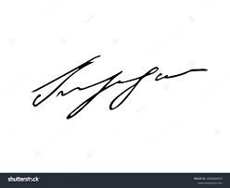
FRCS© NCMP
Clinical Assistant Professor, UBC
Department of Obstetrics and Gynecology SMH

